Prepared by:

**Sohila Mohey**

**Mahmoud Lashin**

**Mahmoud Ali**

**Abdallah Moawad**

**Eslam Ahmed**

**Cars Sales Data Management**

**______**

**Description of Database Design:**

The database design for managing car sales data encompasses the creation of tables, establishment

of relationships between these tables, and definition of attributes within each table to efficiently capture

and store relevant information. This section provides a detailed overview of the database structure, including the tables, relationships, and attributes involved.

# Project Value:

# To clarify, it seems like you're asking how to represent or analyze the "Project Value" in the context of car sales.

# Project Value could refer to various things, such as the total value of a sales project, the expected revenue

# from future sales projects, or the projected value of individual cars within a sales project. Without further context,

# I'll provide a general approach on how you might analyze project value in the context of car sales using Power BI.

## ERD Diagram:

## 

## Create Diagrams:

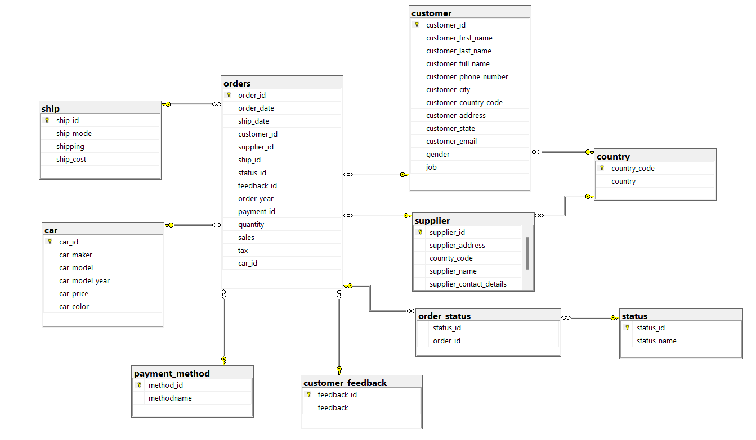

Creating The Data Warehouse:

Data warehousing is a strategic approach to data management that involves the consolidation

And organization of data from disparate sources into a single, centralized repository

for analysis and reporting purposes.

Cars Sales Data Warehouse Schema:

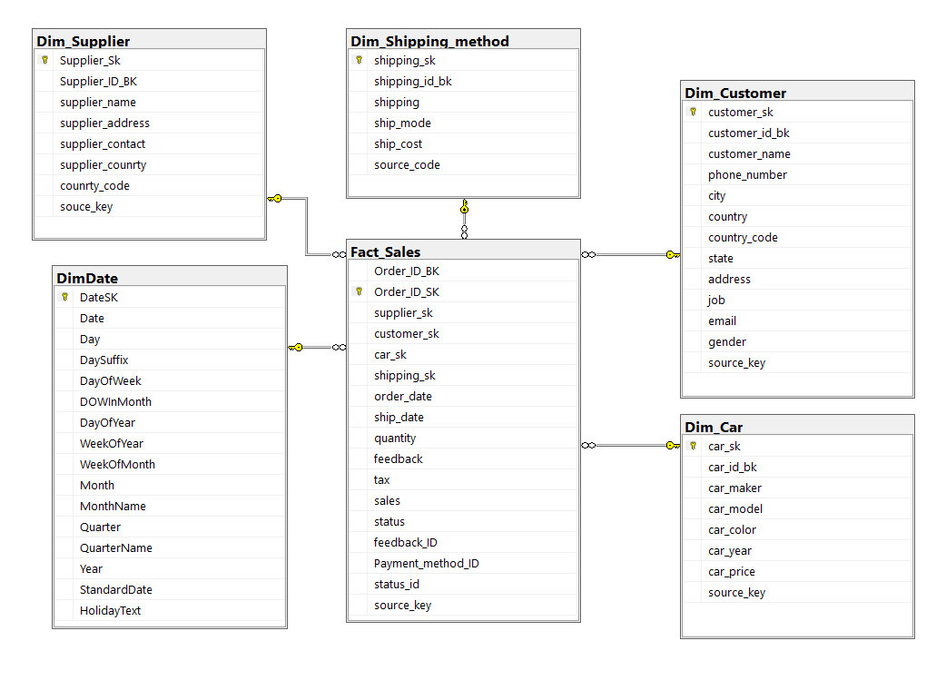

ETL:

SQL Server Integration Services (SSIS) is a powerful data integration and ETL (Extract, Transform, Load) tool provided by Microsoft as part of the SQL Server suite. SSIS enables organizations to build robust ETL solutions to extract data from various

sources, transform it according to business requirements, and load it into destination

systems such as databases, data warehouses, or BI platforms. This section provides an introduction to SSIS and highlights its key features and role in ETL processes.

A sample of SQL queries:

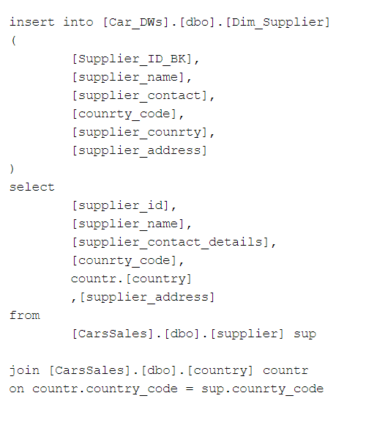

A sample of using SSIS to transfer data into DWH:

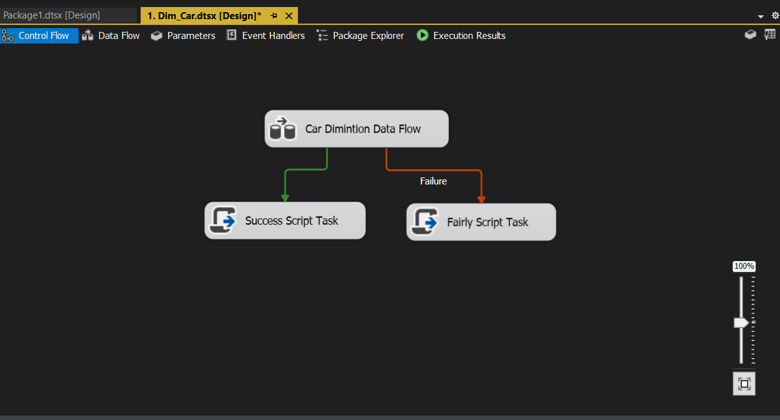

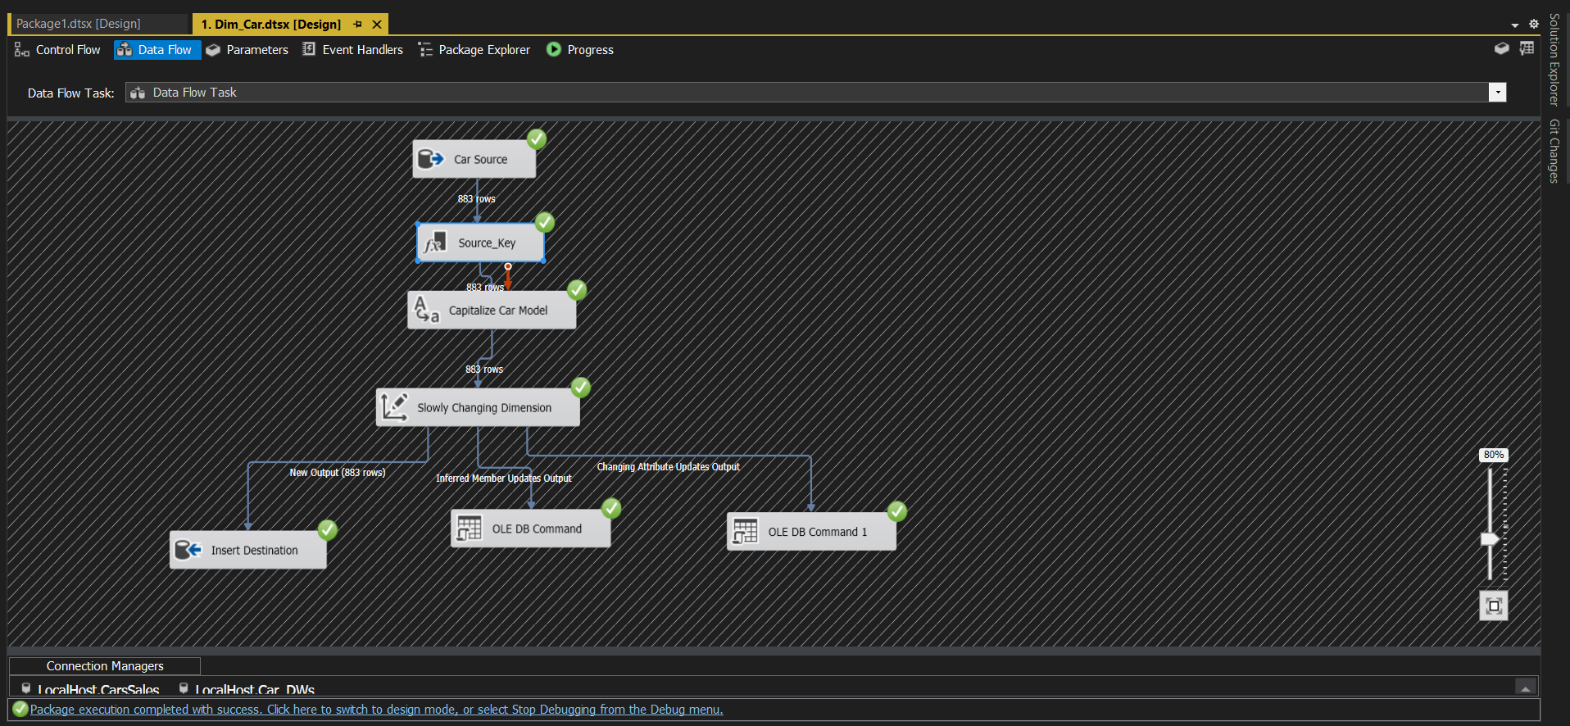

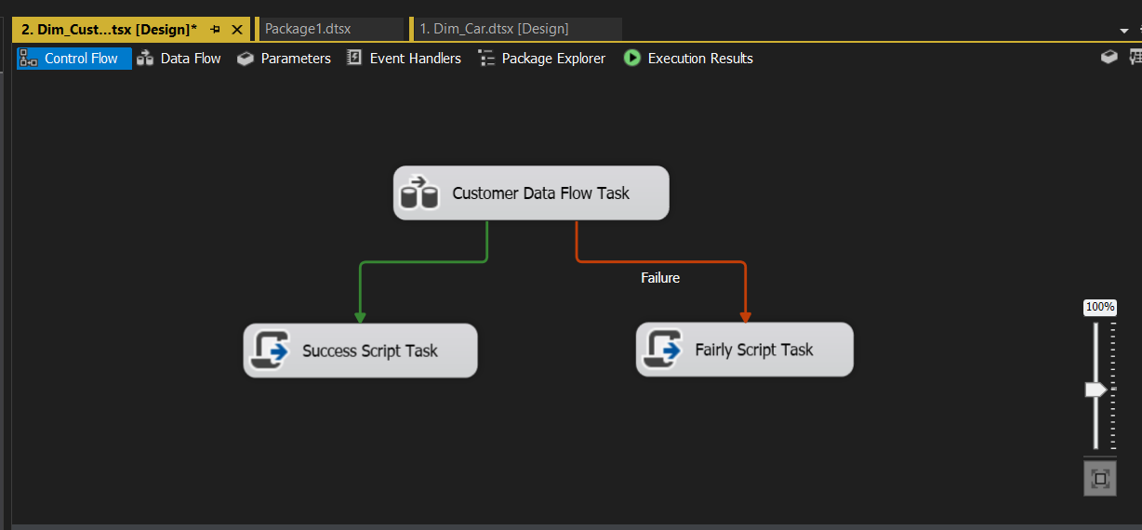

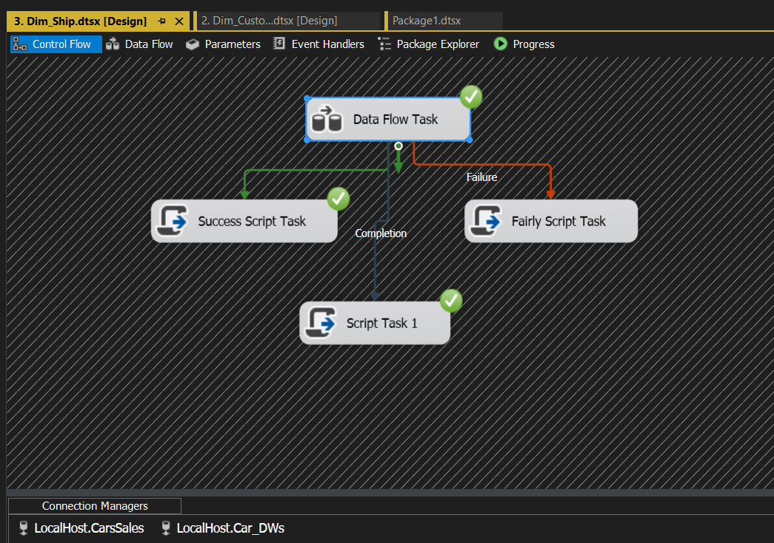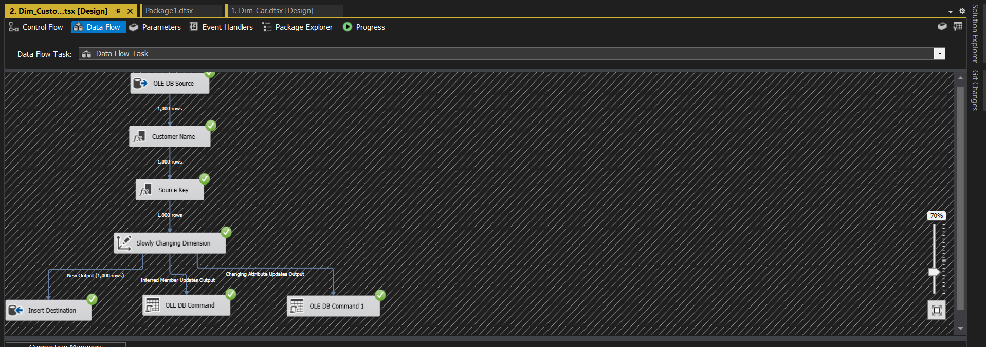



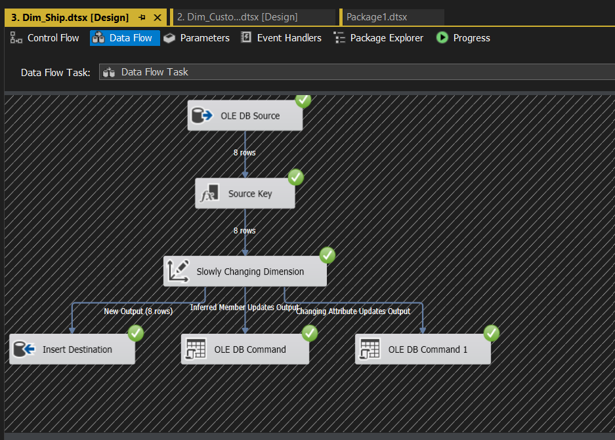

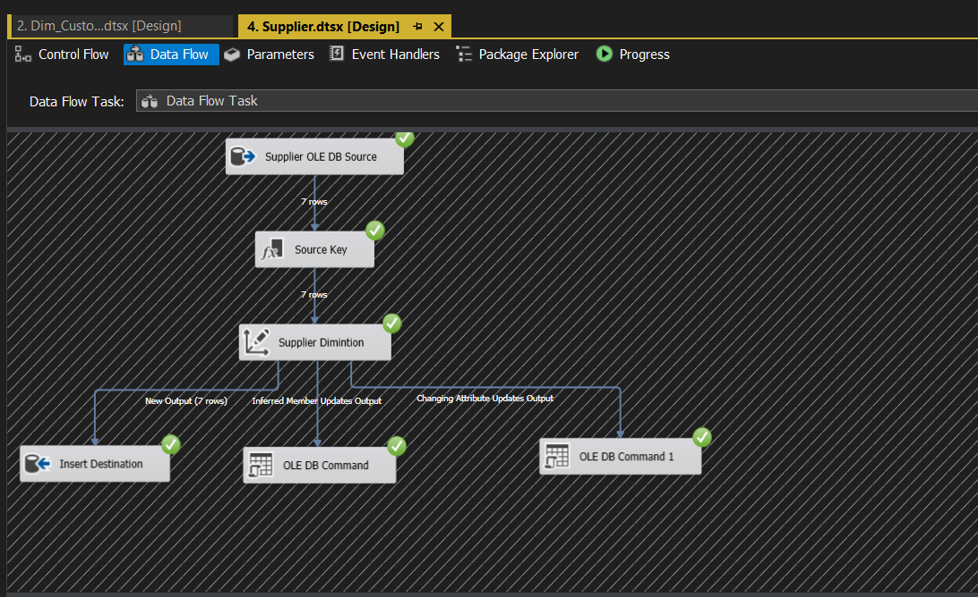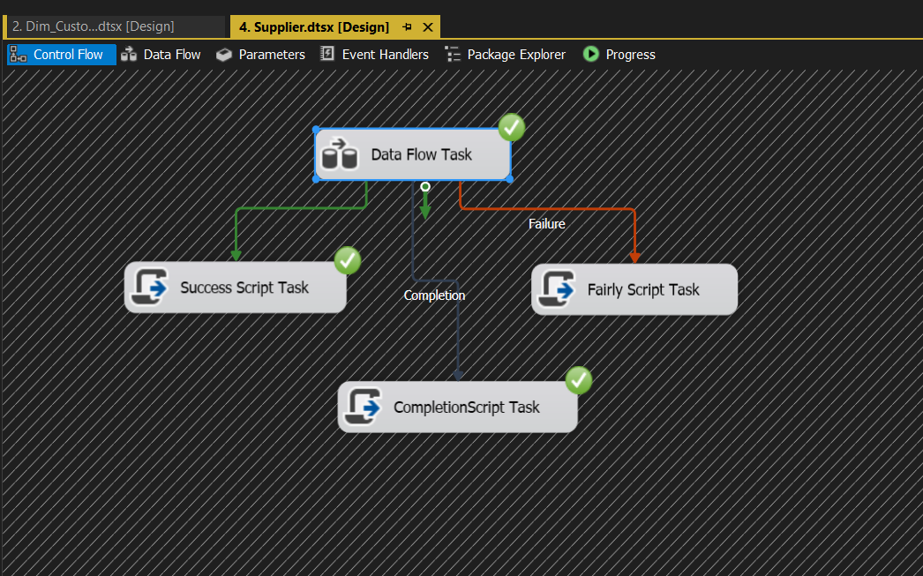

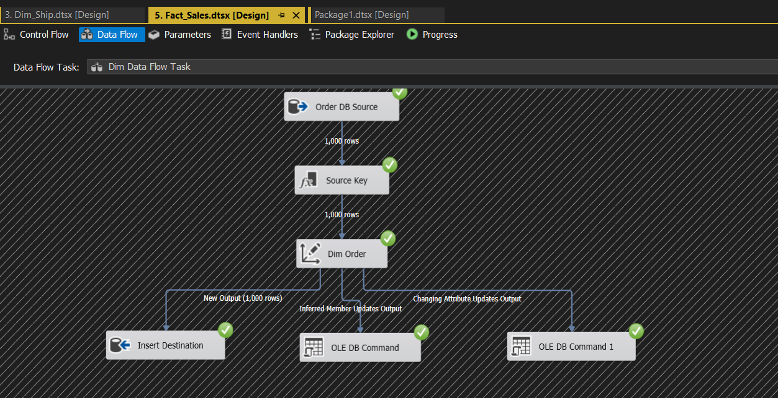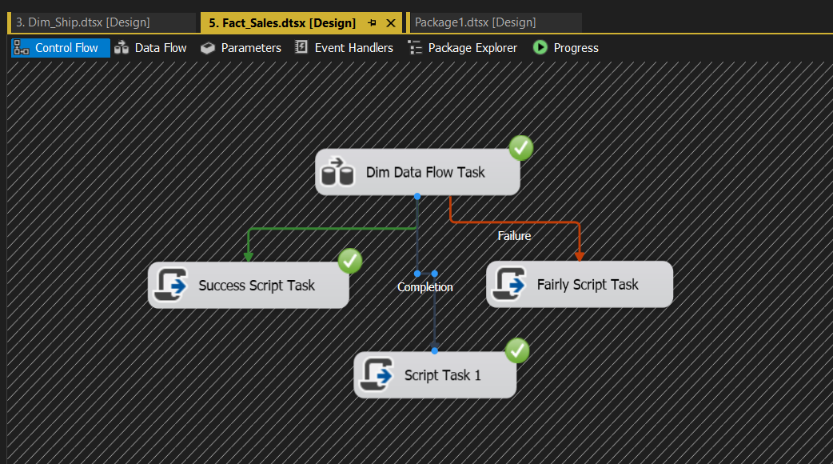

Car Cube:

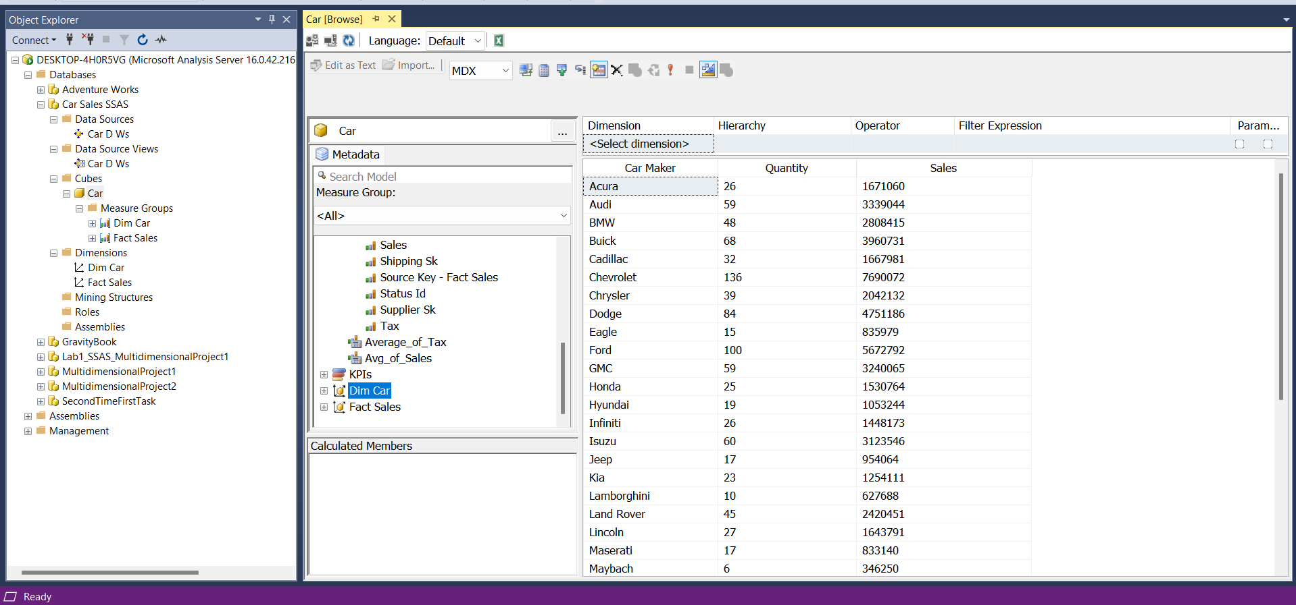

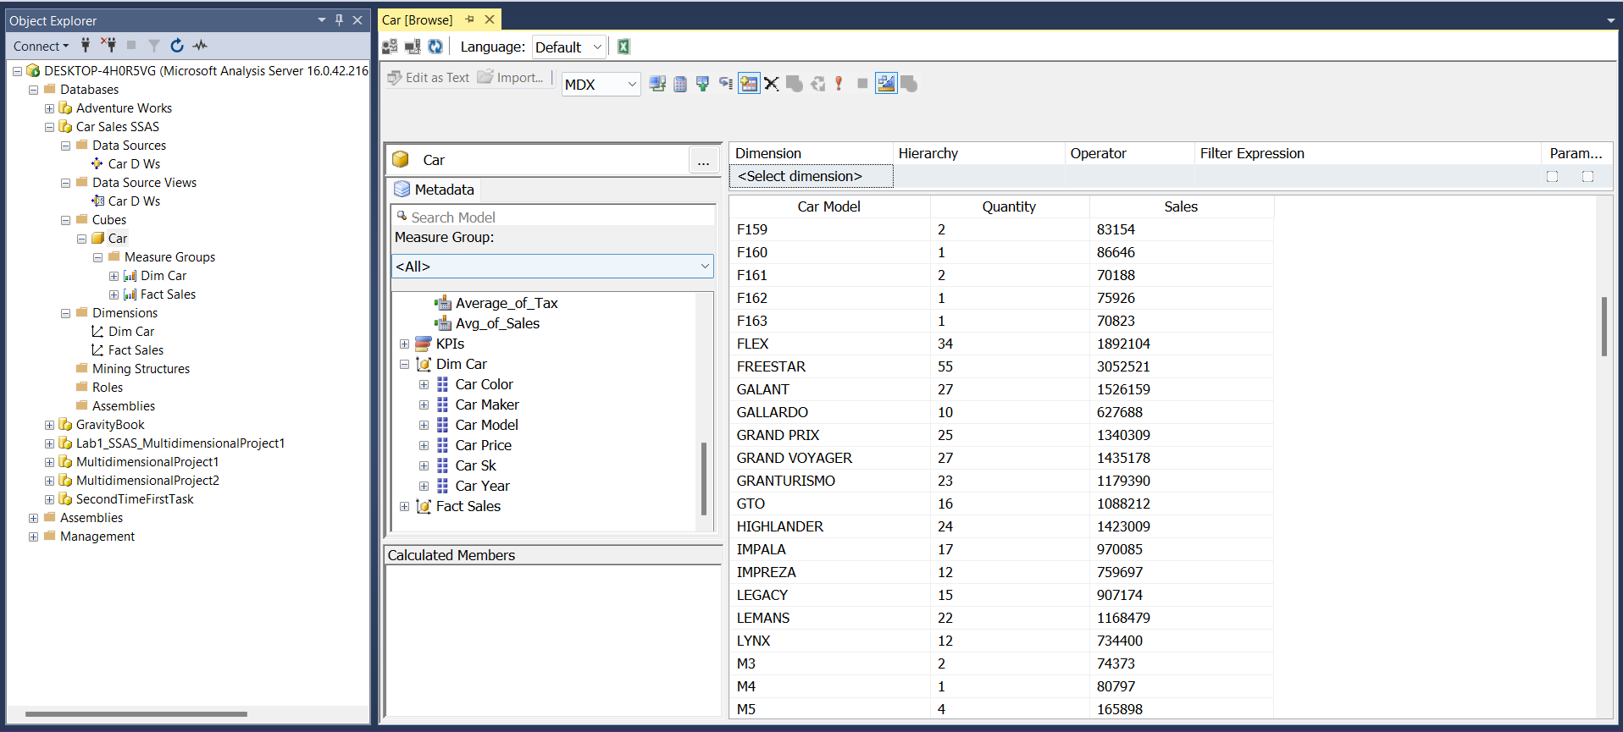

Supplier Cube:

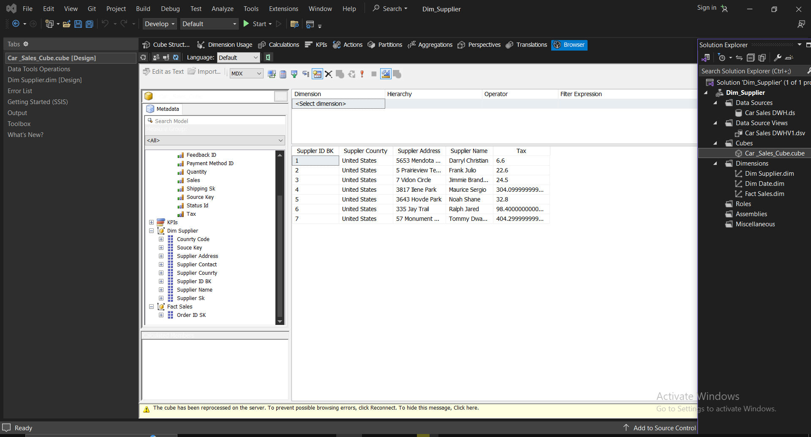

Customer Cube:

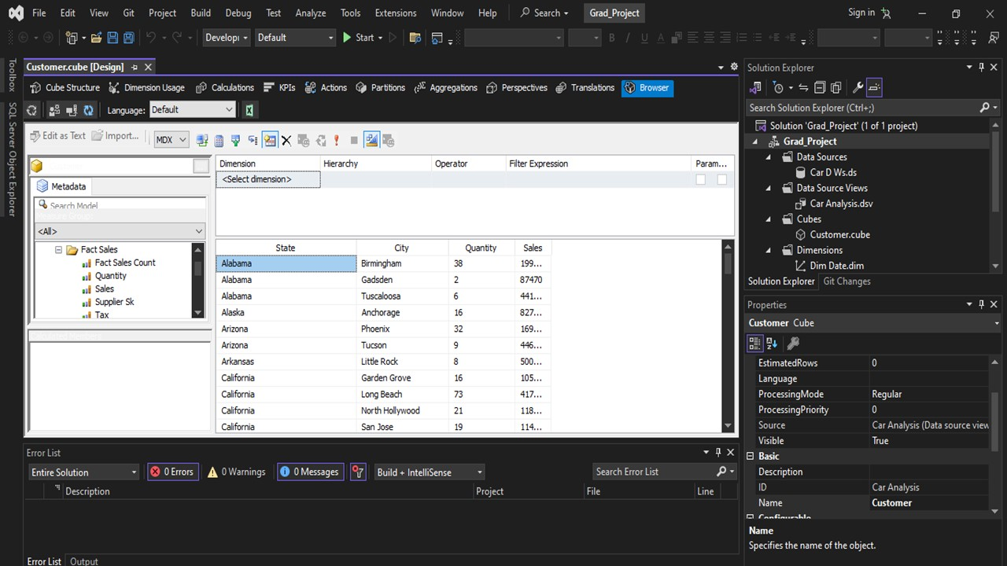

At The End

**Thank you**

